**Project Color Palette Generator**

**Katherine Tuohy (21210963)**

(katherine.tuohy@ucdconnect.ie)



This is version 1.0 of this document. Watch for future revisions. All such revisions will supersede the content of this document.

**Table of Contents**

Section 1: Abstract ……………………………………………………………….. 4

Section 2: Online Access ……………………………………………………………….. 5

Section 3: Introduction ……………………………………………………………….. 6

Section 4: Core Idea ……………………………………………………………….. 6

Section 5: Technical Approach …………………………………………………….. 6

Section 6: Data, Information, Knowledge ………………………………………….. 7

Section 7: Diversity and Divergency ………………………………………………... 8

Section 8: Mere Generation and True Creativity ………………………………... 9

Section 9: Evaluation, Self-Critique and Filtering ……………………………... 10

Section 10: Hits and Misses …………………………………………………………… .. 11

Section 10: Conclusions …………………………………………………………… .. 18

**List of Figures**

Figure 1: Sweet Success ……………………………………………………………….. 13

Figure 2: Blueberry in the Garden ………………………………………………….. 13

Figure 3: Medium Turquoise Pickle ………………………………………………….. 13

Figure 4: Marshmallow Happiness. ………………………………………………….. 13

Figure 5: Denim at the Seaside. ……………………………………………………….. 13

Figure 6: Woods of Magic ……………………………………………………………….. 13

Figure 7: Blueberry at a Pickle Jar …………………………………………………….. 14

Figure 8: Peas of Lemonade ………………………………………………….. 14

Figure 9: Barney in a taxi ………………………………………………….. 14

Figure 10: Rubber Duck at a Blueberry Patch ……………………………….. 15

Figure 11: Cerulean Blue and Cherry Blossoms ……………………………….. 15

Figure 12: Mystical Swimming Pool ………………………………………….. 15

Figure 13: Flamingo Peacock …………………………………………………….. 16

Figure 14: Peas and Seas ………………………………………………….. 16

Figure 15: Grasses of Water ………………………………………………….. 16

Figure 16: Trees of Intellect …………………………………………………. 16

Figure 17: Tree in the Sky ……………………………………………………… 17

Figure 18: Grape at the Garden ………………………………………………………….. 17

Figure 19: Warm Blueberries ……………………………………………………… 17

Figure 20: Hopeful Seaside ………………………………………………………….. 17

**List of Important Abbreviations Used Within**

GUI: Graphical User Interface

**Abstract**

Color Palettes are important for branding, cohesiveness, and in a variety of other circumstances. Giving palettes names makes them not only referable but more memorable. Naming colors is a difficult challenge because different people interpret colors differently. This project explores the different associations English speakers have with certain colors and how those ties can be used to name randomly generated color palettes.

**Online Access**

GitHub Repository: <https://github.com/katetuohy/ColorPaletteGenerator>

**1. Introduction**

This project produces a color palette of randomly chosen colors and gives that generated palette a name. The name produced is based on cultural associations English speakers have with the colors present in the generated palette. The aim of this project is to produce a name for the generated palette that is familiar to the user but not obvious.

**2. The Core Idea**

Color palettes are important to humans because colors are important to us. We all have our own ideas tied to the colors we see in the world and different understandings of those colors. Often, cultural influences cause people within that cultural to have similar associations with colors. Thus, people and companies will leverage those associations in branding, interior décor, and other likewise settings to draw certain emotions from those interacting with their subject.

When companies are choosing a color palette for their brand, or interior designers are choosing colors to fill a room with, they have endless options. This project aims to produce color palettes they could use, as well as names for the color palettes. By naming the palettes, they are not only more easily referable, but also more memorable. Through the compilation of associations made with colors, we can produce names based on the colors generated in the palette.

While the English language has eleven basic words for colors (black, white, red, green, yellow, blue, pink, grey, brown, orange and purple), that is not the case for all languages. For example, both Greek and Russian have two separate words to distinguish between light blue and dark blue. In short, the language you speak affects how you view and understand color. Even amongst English speakers, we have our own biases and cultural backgrounds that influences how we categorize a color. The difficulties that arise from this nuance will be discussed further on.

**3. Technical Approach: Architectural Perspective**

I started off by building a React App to produce a randomly generated color palette of a size specified by the user. This was not a quick as I had anticipated as I ran into some rendering issues with the boxes the colors were in. Once I had the GUI running the way I intended, I started thinking about how to implement the naming.

I started by compiling a list of attributes culturally tied to each of the eleven core colors. Given this basic JSON of color attributes, I hesitated on how to begin. Since the generator I had built was in React/JavaScript, I used a Tracery npm package to flatten the colors JSON and make the values accessible from the App. I knew that I wouldn’t have a simple #origin# since I needed the palette names to be conditionally rendered based on the colors in the palette. Thus, I started out by using a simple while loop to produce a list of the most common shades in the palette and then use the first two to produce a name.

Once I figured out I could concatenate the names of the shades with the rest of the Tracery String, and that I didn’t need to build many switch/case statements to handle the conditionals, the implementation became much easier. In place of an #origin#, I produced a list of Strings containing the Tracery requests. I then randomly selected the String to be set, in the same way that Tracery functions with its #origin#.

**4. Data, Information, Knowledge**

The lists of color associations came from a range of websites that listed these ideas tied to the colors and was filtered through my own biases as an American living in Ireland. I also included adjectives for pastel colors to include in the case that there are multiple pastel colors in the generated palette.

One of the biggest challenges of this project was compiling examples of the eleven basic shades. I used Daniel Flück’s Color Name and Hue JavaScript file as starting point for categorizing the shades. This was the only tool I could find on the internet that did this type of categorization. While testing it out, I quickly realized it was not categorizing shades as I would have expected. There were very few browns, as they were often noted to be reds, yellows or oranges, and there were few greys, as they were noted to be greens or blues. To improve this categorization, I would generate a palette and check to see if the shades produced matched what I would have expected. If they did not, my first step would be to check the name of the color they were most closely matched with to see what shade that color had been noted as. If that matched what I expected, then I would make a new example with the generated color. If the existing example did not match my expectation, I would change the shade that it had been assigned. This was an incredibly time-consuming process that I had not anticipated as I had assumed the categorization would be more accurate but doing so lead to better results as the names were actually tied to the colors produced.

Additionally, Flück’s list did not include the shade pink, which is classified as one of the basic eleven colors that English speakers recognize and thus have associations to. I added Pink to the list of shades and then went through the existing Red samples, checking whether that Red was actually Red or if it could be classified as Pink. When generating palettes in testing, I noticed some Pinks were being classified as Violets, so I then went through and changed those Violets to Pinks.

Throughout this process, I was only thinking about how difficult this classification was. I would run into instances when I did not know whether I would personally note a color as an orange or a brown, a yellow or a white, a grey or a green. Often, the case could depend on the other colors in the palette generated and how the classification of that one off-color could lead to more cohesiveness by leaning one way rather than the other. This nuance causes issues when it comes to naming because the colors on the border often evoke different feelings than those that are clearer examples of a shade.

**5. Diversity and Divergence**

Psychologist J.P. Guilford proposed a concept of ‘divergent’ thinking, for which he saw having four key traits: fluency as the ability to produce a great number of ideas or problem solutions, flexibility as the ability to simultaneously propose a variety of approached to a specific problem, originality as the ability to produce new original ideas, and elaborations as the ability to systematize and organize the details of an idea as well as carry it out (Guides).

In terms of the system I have created, I would hold that it does have fluency due to the vast number of palette name possibilities. It lacks flexibility in that there are constraints on naming color palettes and thus there are only so many approaches taken.

With more time, it would have been interesting to classify some of these colors as more than one shade in instances where that could be the case. This would have led to more flexibility in the naming, such as in cases where the sway might lead a shade to have more influence in the name due to its frequency in the palette.

This project has an element of elaboration from taking the generated hex code, finding the closest matching shade, and then using that shade in its naming. In that sense, it organizes the details of what has been produced to then use those details in the solution.

Originality is the hard concept to pinpoint since defining what is original is difficult. Since these names produced are intended to evoke a feeling of familiarity without being obvious, ideally the names produced would be original. However, since the English language has so few concepts that we very strongly associate with colors, producing new ideas is hard. In some cases, yes, the system does have some original names but in many, there are names that are already likely tied to other color palettes out in existence.

Thus, even if these names are not entirely original, they have a strong meaning that correlates with their usefulness. If the names were entirely out of left field, then they would lack the usefulness that comes from that familiarity, even if some of the names produced are more obvious and less original than intended.

**6. “Mere” Generation and “True” Creativity**

This system is much closer to mere generation than it is to true creativity as there are no instances when it transcends its own built-in rules. Much of this was due to a time constraint as I had intended to implement a layer of evaluation/filtering on the first generated name but ran out of time.

It’s important to note that average humans would also generate names for these palettes in a similar way. Without background cognitive knowledge of color associations, most humans would simply take a couple basic words they associate with the boldest colors present in the palette to name the palette. After a while, they would start repeating those basic words because there are only so few words they strongly associate with the colors. They would have a stronger ability in naming two or three bold colors in the palette that have ideas tied to the combination of those colors. For example, ying-yang for black and white or Christmas for red and green. But in the end, there seem to be bounds on what we would reasonably name the color palettes while those names remained relevant to the context. That is to say that being creative in this context is challenging but also that this system has potential to become more creative than the average human.

**7. Evaluation, Self-Critique and Filtering**

There is no internal evaluation process built into this system since I ran out of time to implement one. My plan to implement one was to take the name produced and have the system produce the shades that it thinks would be in a palette of that name. This did not feel like enough of an evaluation in my mind as I would have had the system use the color association lists to determine the present shades.

Judging the produced names of these color palettes is difficult. The goal from the beginning was to create names that are familiar yet not obvious. I as a human struggled with this in my manual testing. Palettes can be named anything and therefore, it begs the question of what is a good palette name versus a bad one. All the sites online that have named palettes don’t have well named palettes, or novel ones either. This lack great existing examples of named color palettes not only leads to the question of the necessity of this project but also how good are the names my system produces. However, it does lend to the notion that these are novel names though.

This project is somewhat P-Creative in the fact that there are a finite number of color palette names that could be produced from the words available and number of possible structures. However, that number is so great that to the naked eye, it would seem that a palette name would never be repeated. Thus, each name seems to be novel and therefore the system has the sense of being P-Creative.

In terms of being H-Creative, it seems unlikely that there has never been the same name used for a color palette. However, it can most definitely be said that the name produced has never been tied to that exact palette and will most likely never be again.

**8. Hits and Misses**

One hit that I am proud of is the implementation of the pastel naming. I had to research how to tell whether a produced HEX code could be considered pastel, implement that logic, and then determine how often I wanted to deem a palette “pastel enough” to warrant the use of a pastel adjective in its name. I choose to use pastel adjectives when the palette was around one-third pastel, which seems quite pastel to the eye. Another hit is the use of a specific color name along with the max element. This not only adds many more options for the #origin# but also incorporates more specificity into the name, so it’s more strongly tied to the palette.

One miss is the lack of two-color associations. The idea I wanted to implement after the evaluation step was to produce lists of words that are tied to two shades, such as soccer ball for white and black or watermelon for pink and green. Another miss is the sometimes wanky sentence structures as the words in the Noun lists, Things lists, and Places lists are not so similar as to be referenced exactly the same.

While testing, I would generate palettes of size 3, 5, and 8. Below are examples of all three types of palettes. “Sweet Success”, “Marshmallow Happiness”, and “Warm Blueberries” are great examples of how well the pastel naming process went. “Blueberry in the Garden” is a tough one because you can see that the system sees the first shade as blue, yet it is not the same shade of blue that we typically associate with blueberries, which are typically darker and have less green in their color. “Medium Turquoise Pickle” is by far the worst of the bunch since including the name of a color can be quite hit or miss. In this case, the name of the color is not appealing nor is its combination with the Pickle, though it is relevant to the produced palette. I quite like “Woods of Magic”, which combines the brown and the purple while not feeling too far off from the turquoise included.

In terms of the 5s, I find “Blueberry in a Pickle Jar” to be my favorite out of the ones produced, and then “Mystical Swimming Pool” as my second favorite. “Barney in a Taxi” is awfully funny, but the yellow seen there is not the same version of yellow that is typically associated with taxis, and thus the name is not as strongly correlated with what is seen in the palette. “Cerulean Blue and Cherry Blossoms” is a good example of when using the specific color name can work well.

For the 8s, “Peas and Seas” is a favorite purely for the rhyming aspect, though it doesn’t strongly correlate with the produced color palette due to the pinks and violets present.

“Grasses of Water” is the worst name out of all, and it is not surprising that the worst is an eight palette. As the number of colors included in the palette increases, the correlation between the palette and its name begins to decrease. This is due to the way I set up the naming process in which only the first two most frequent shades in the palette are used in the name.

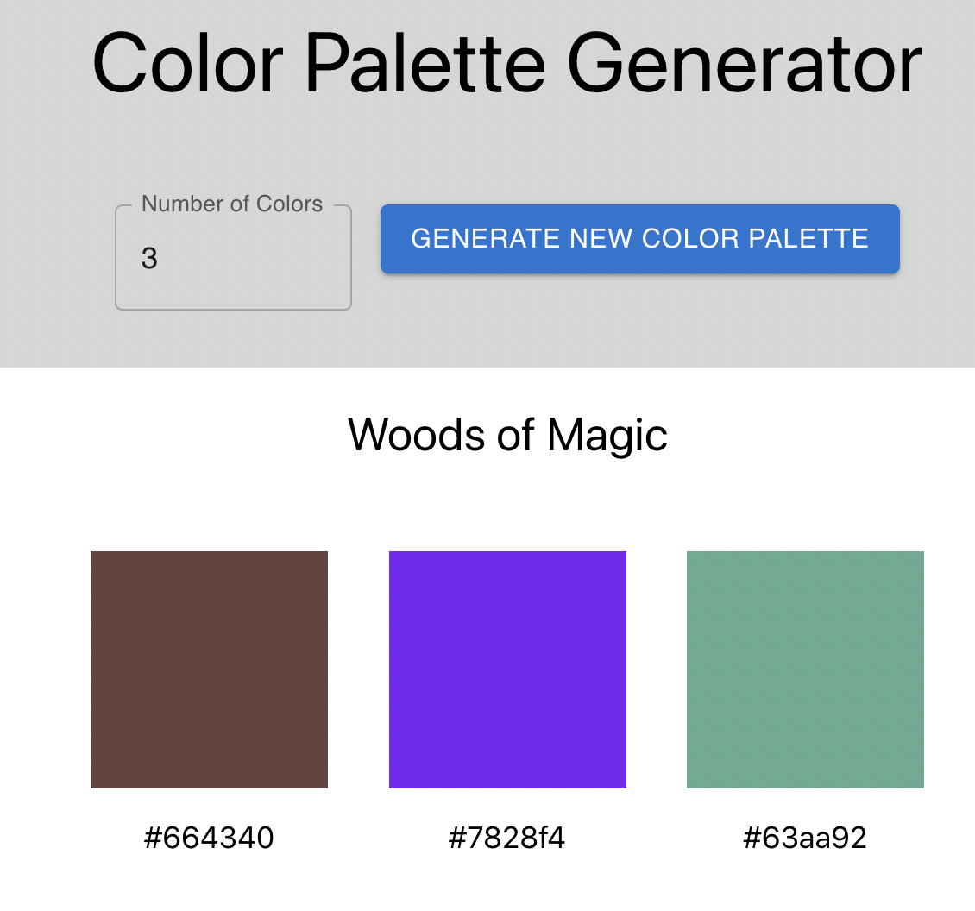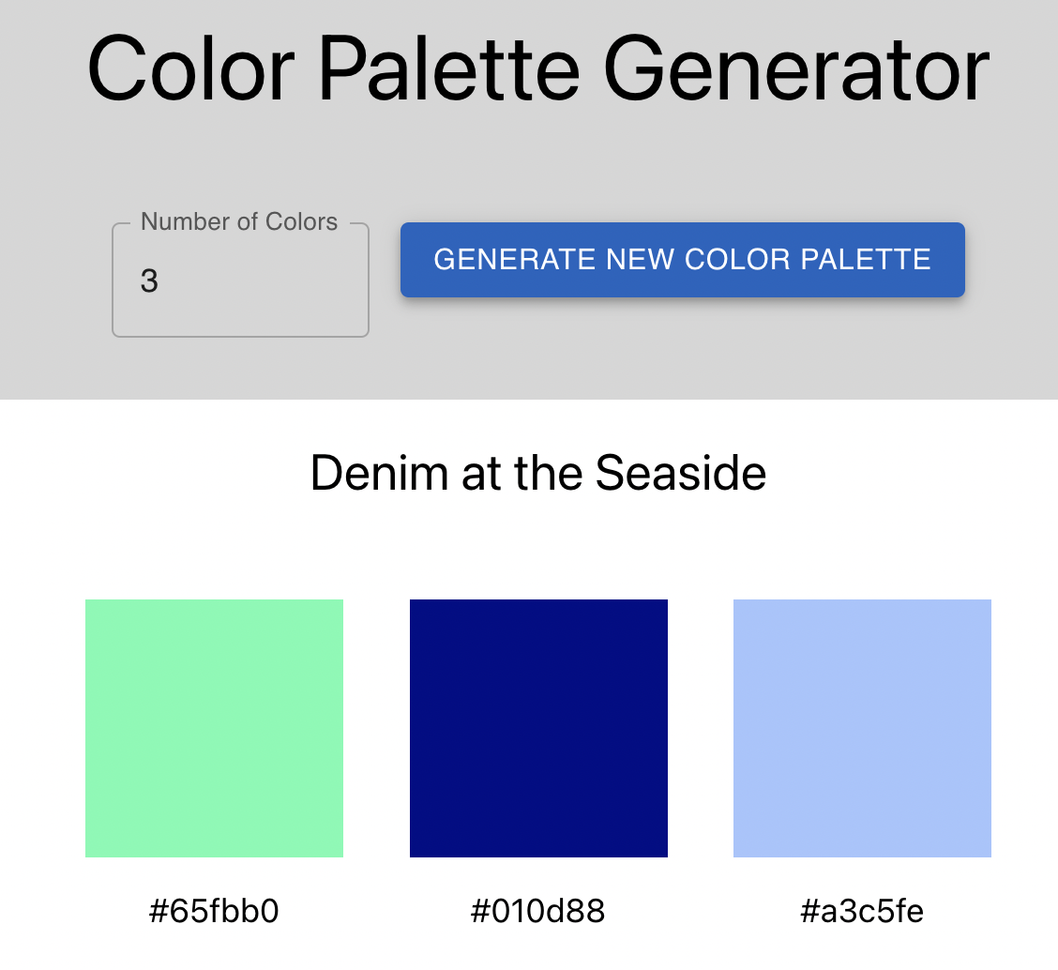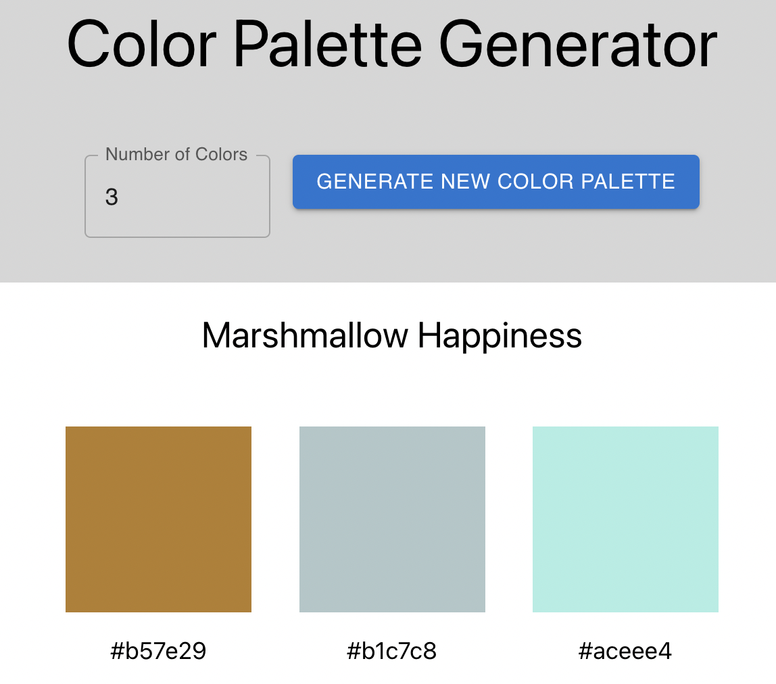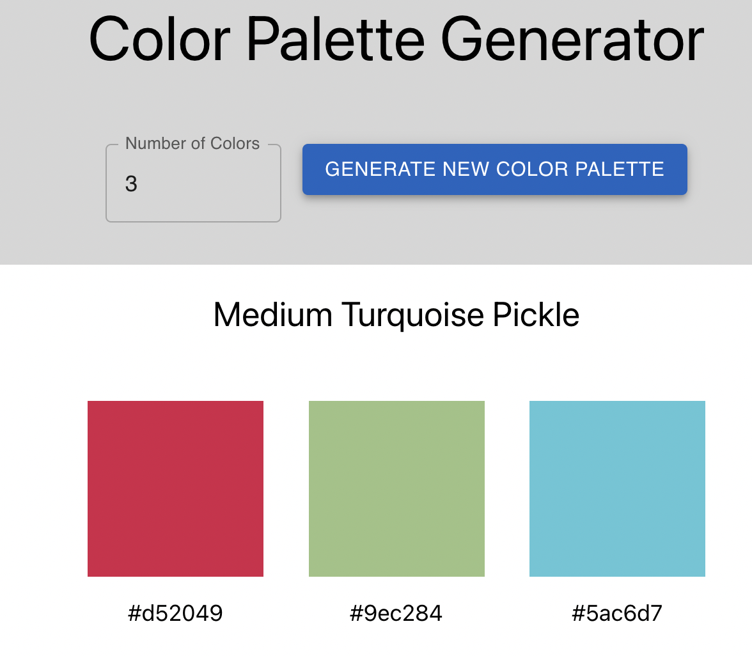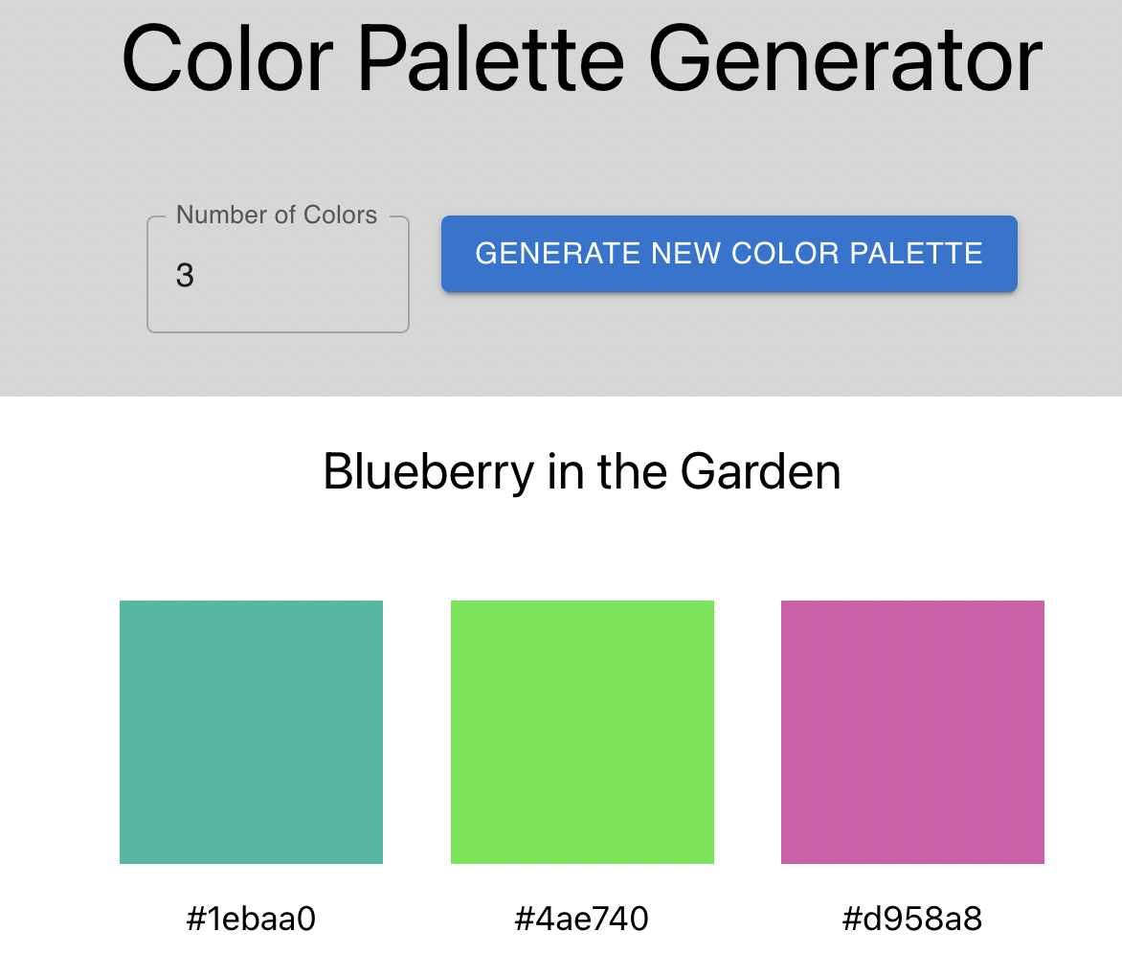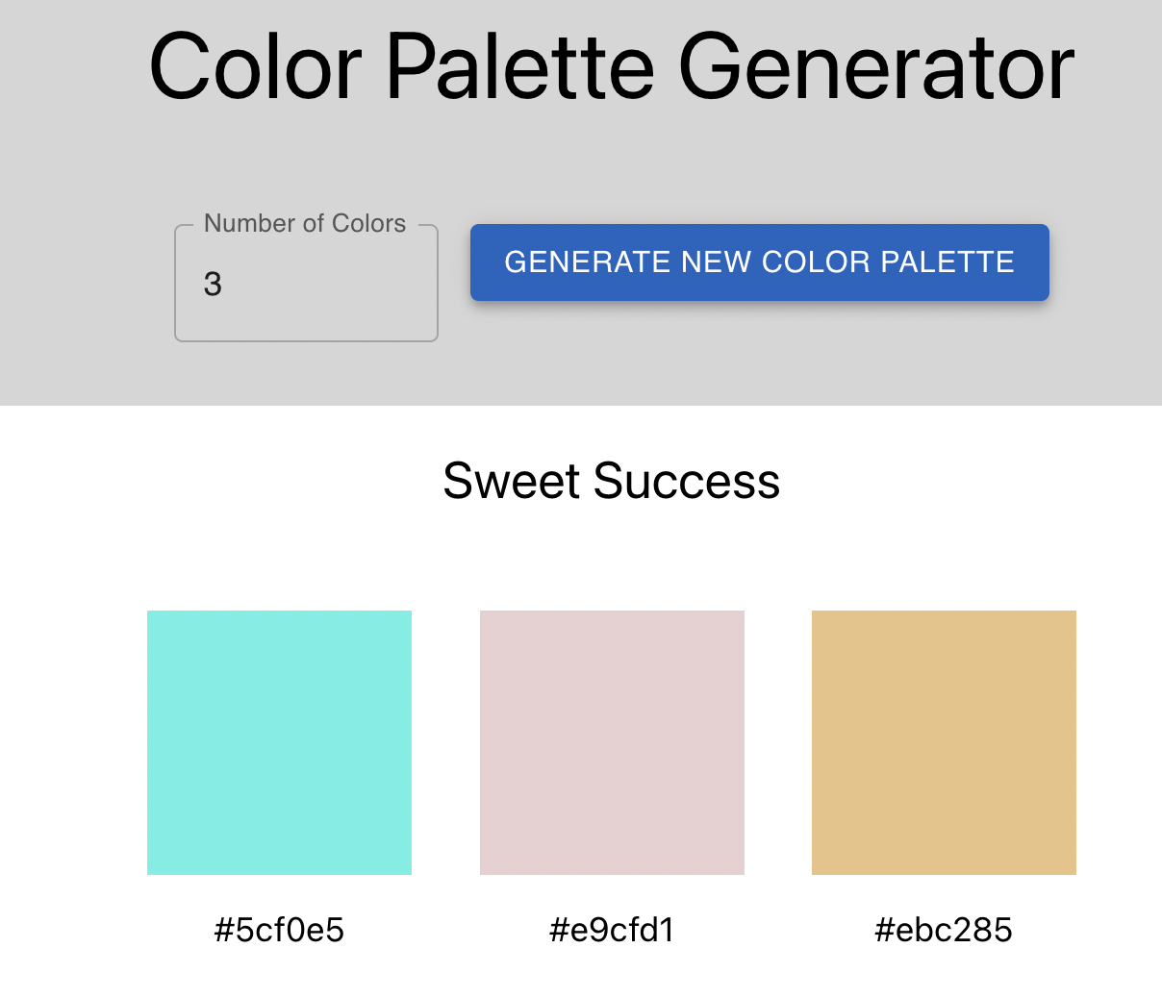

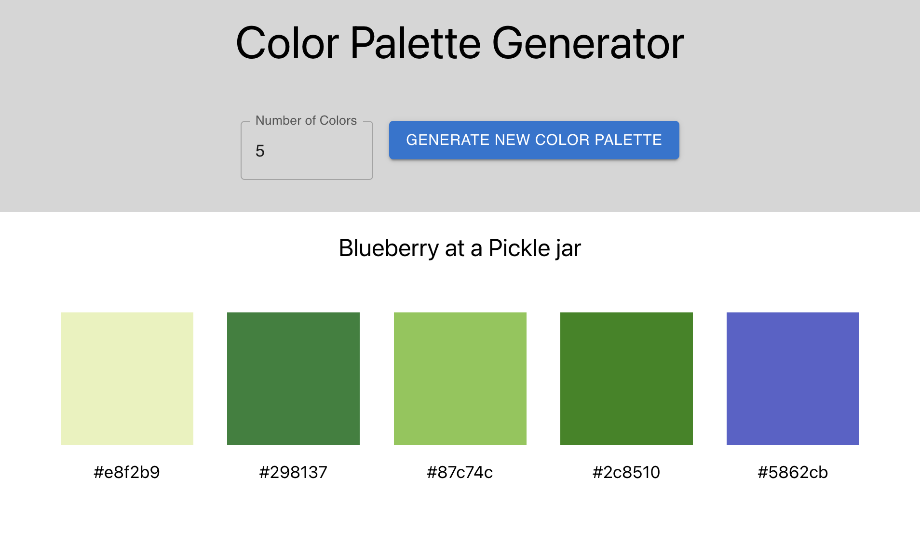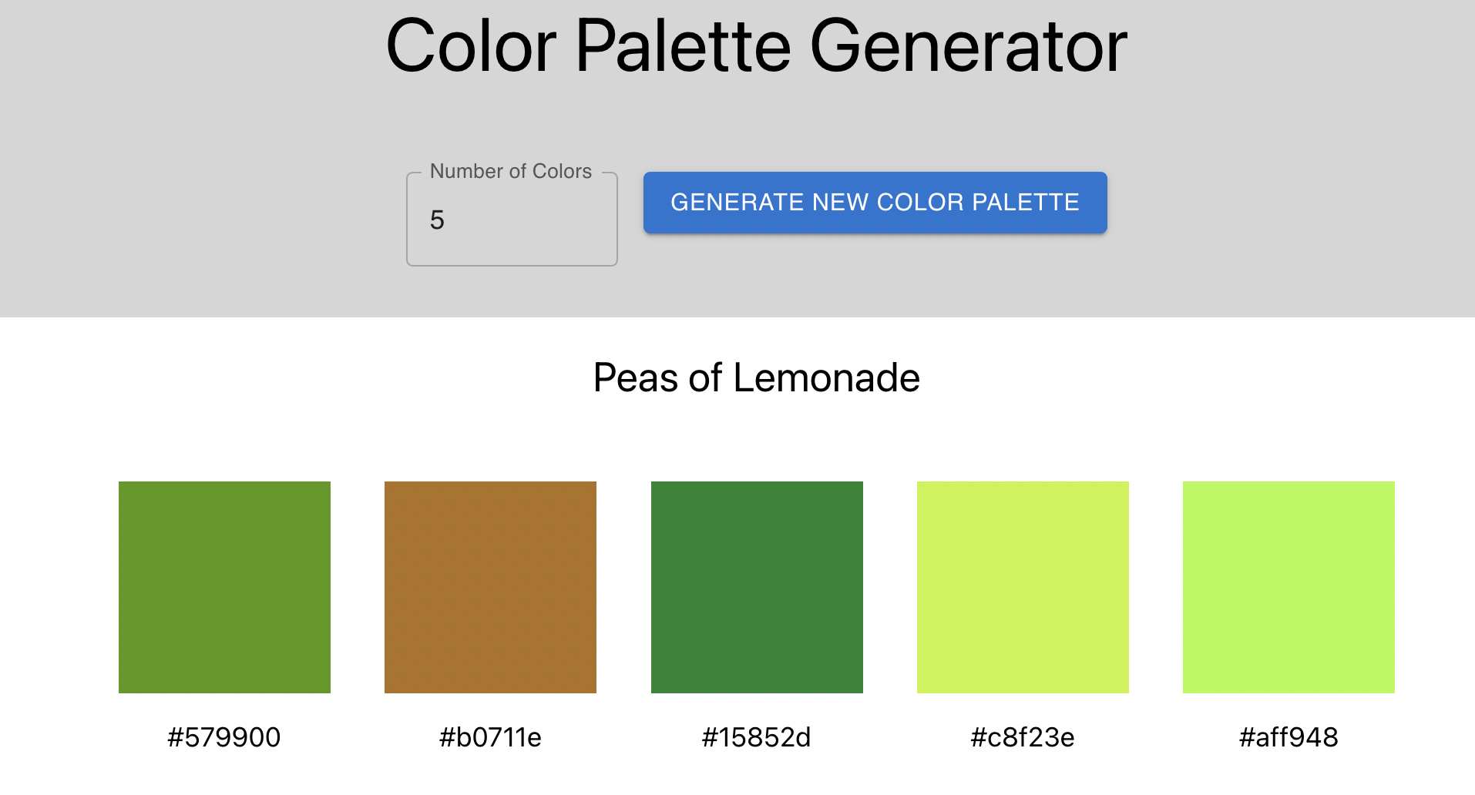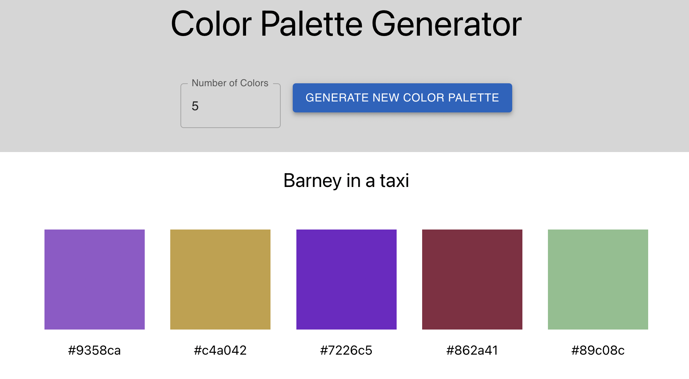 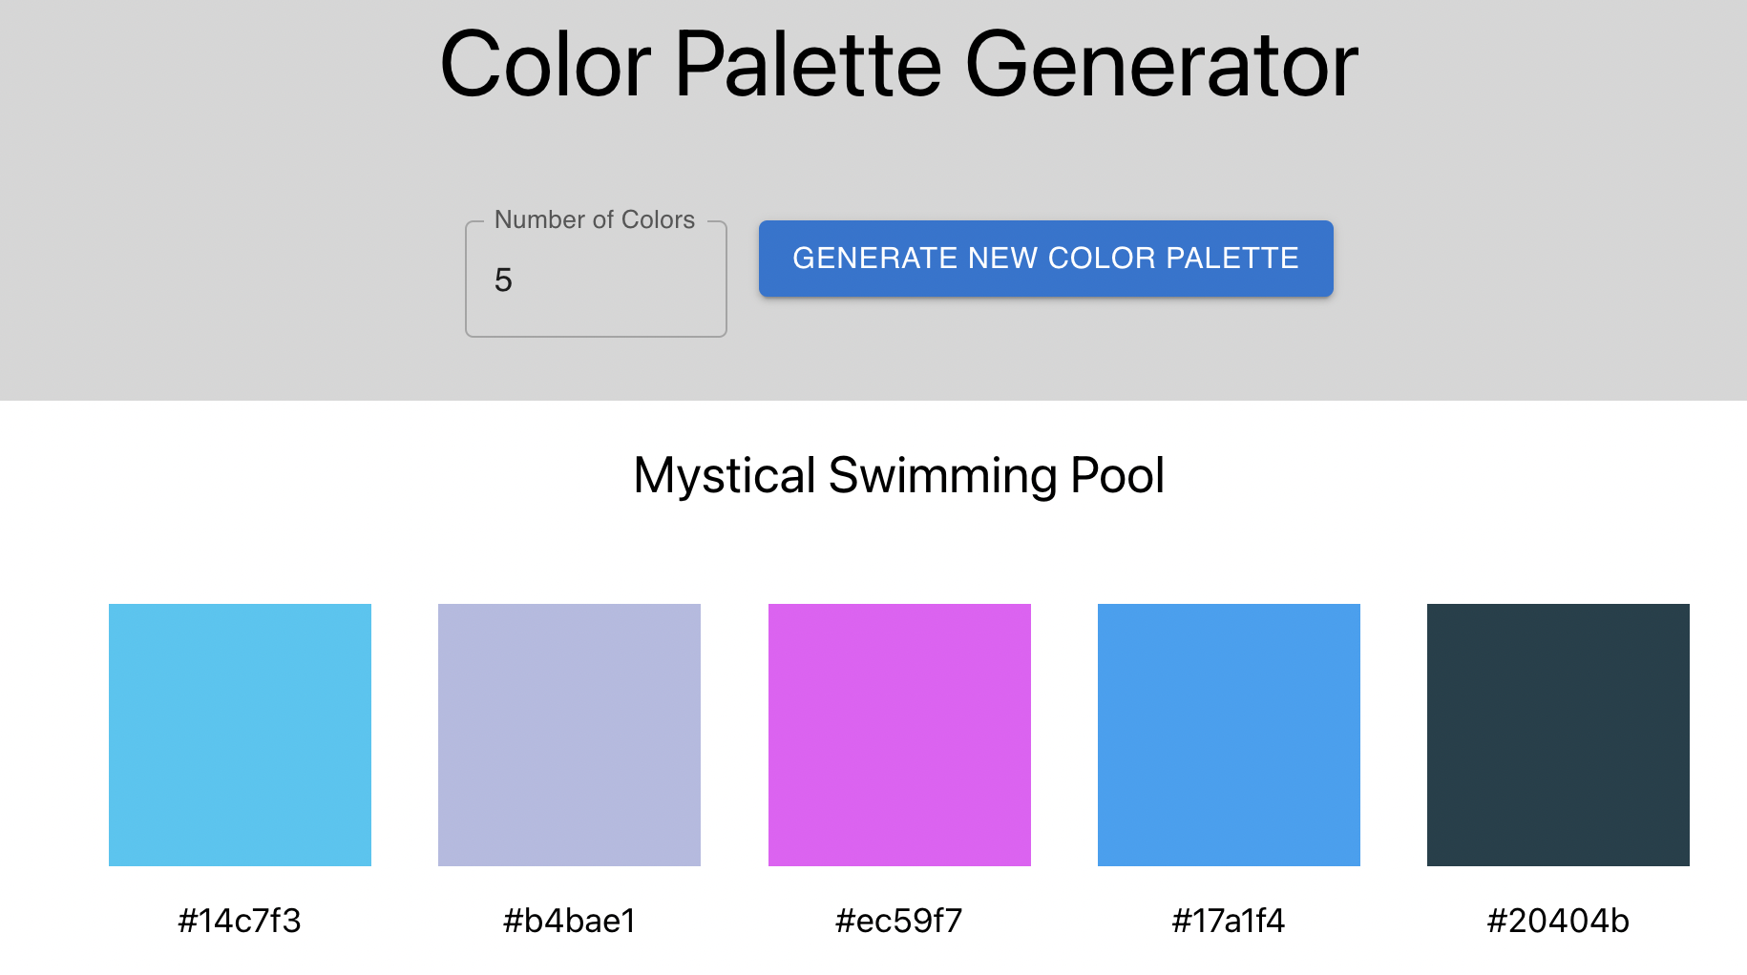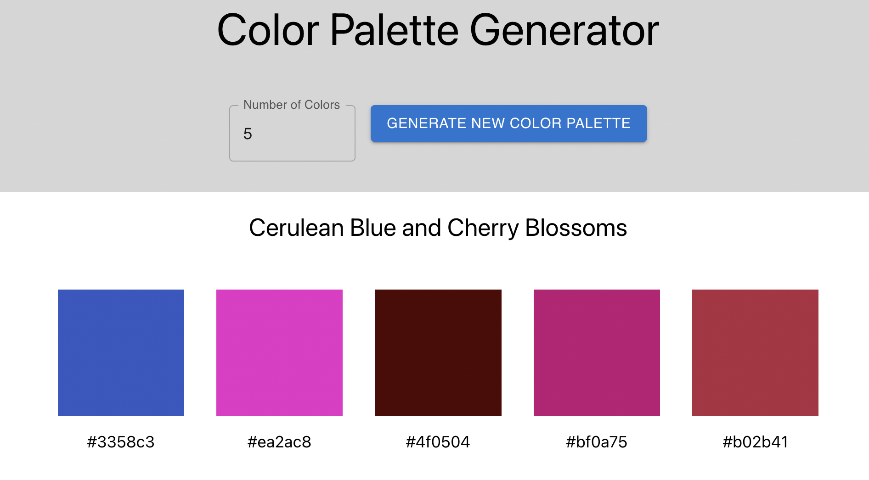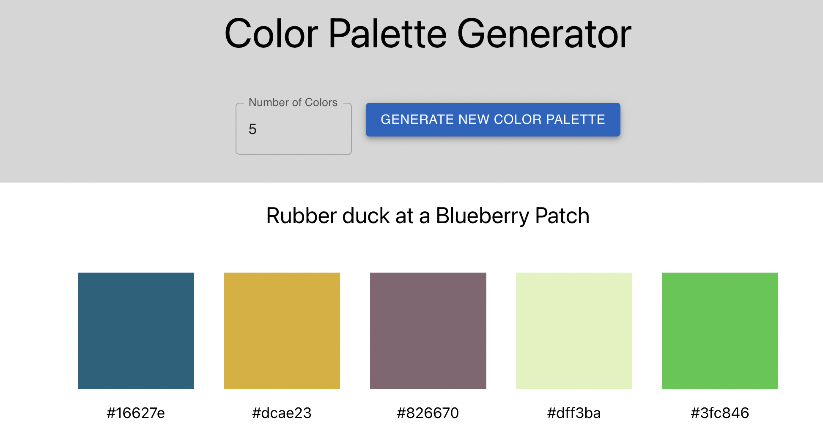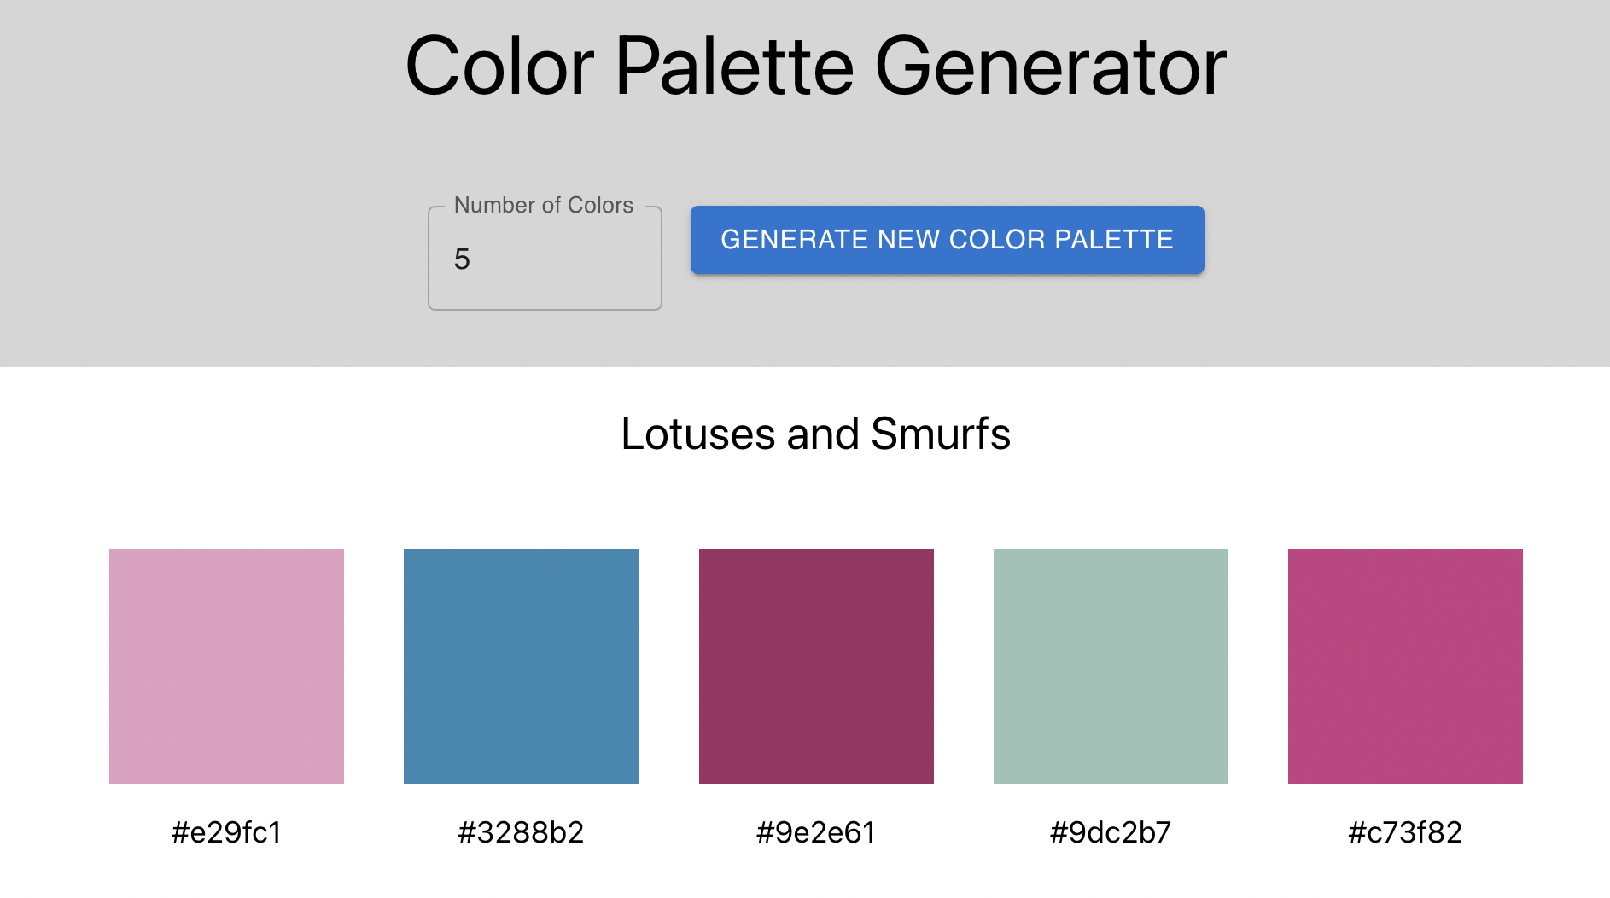

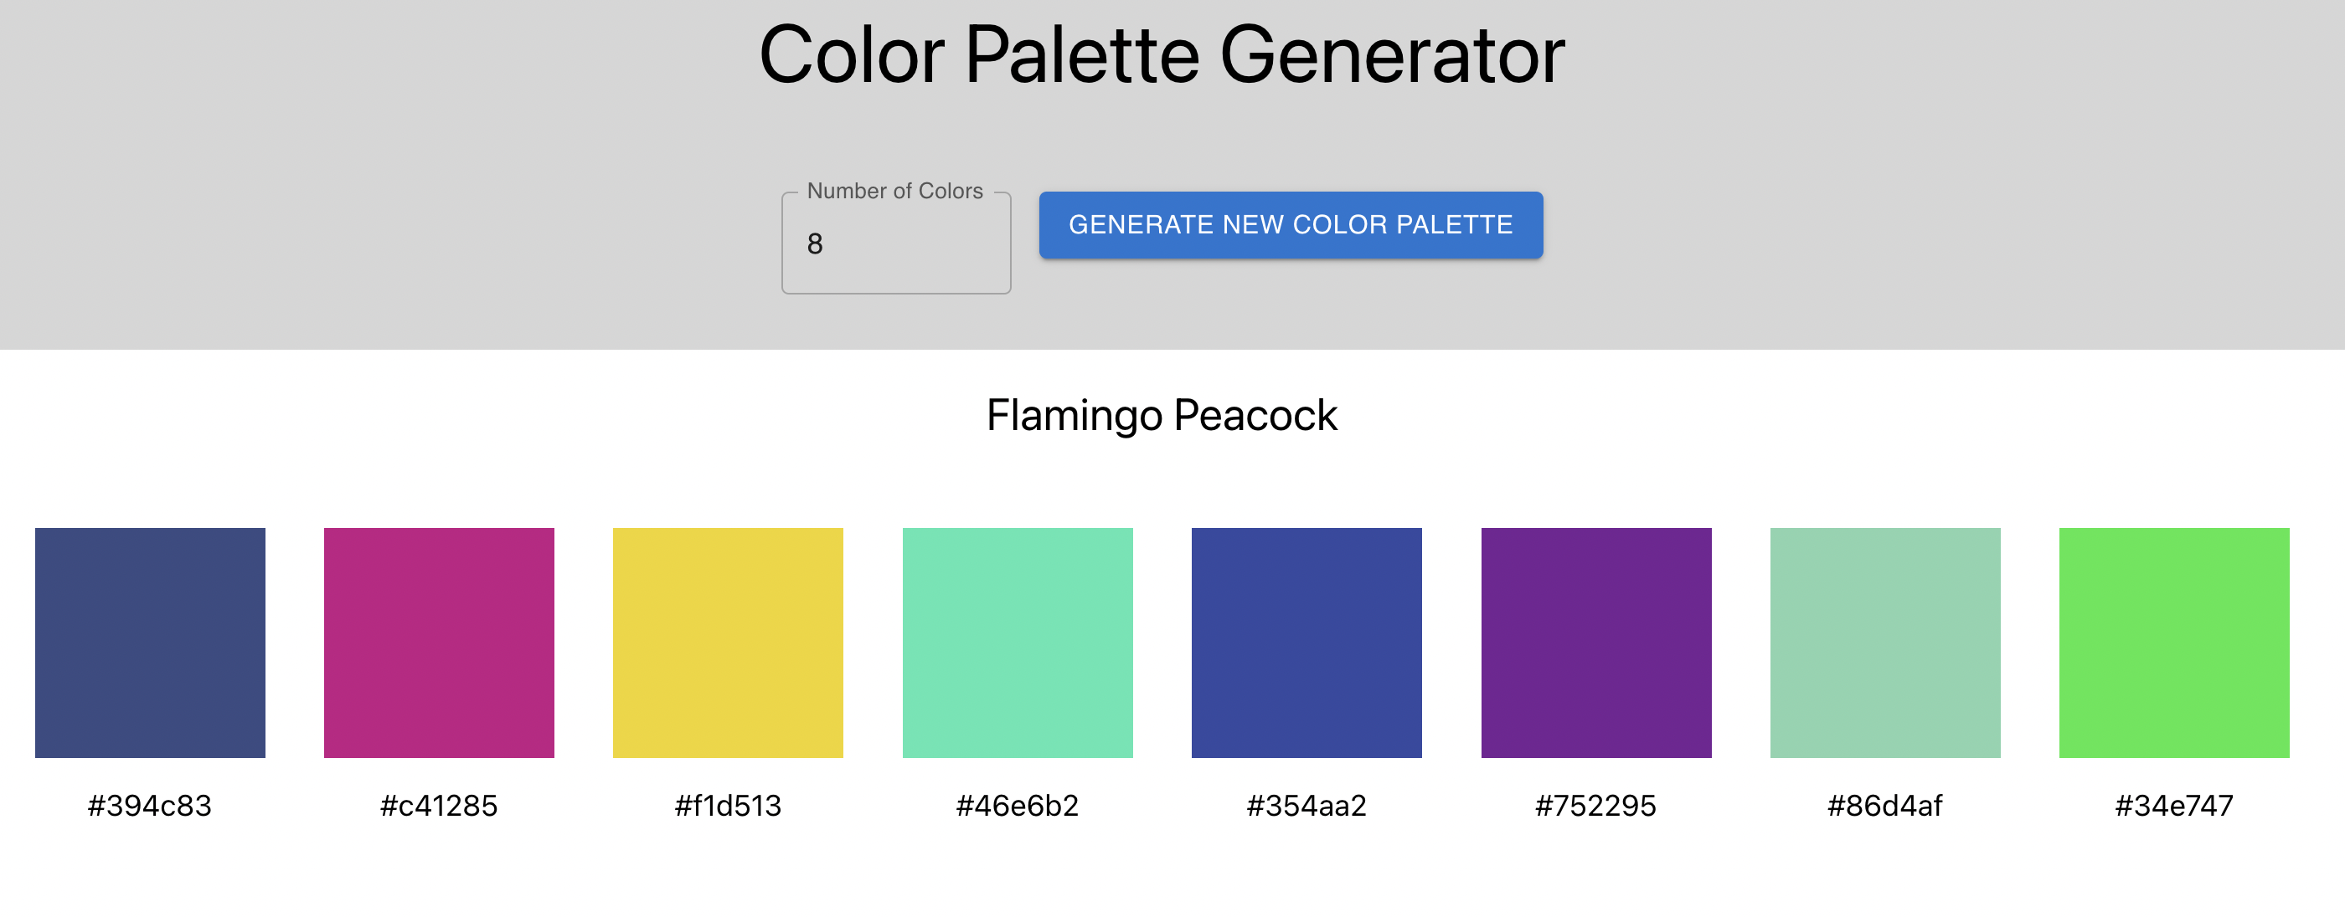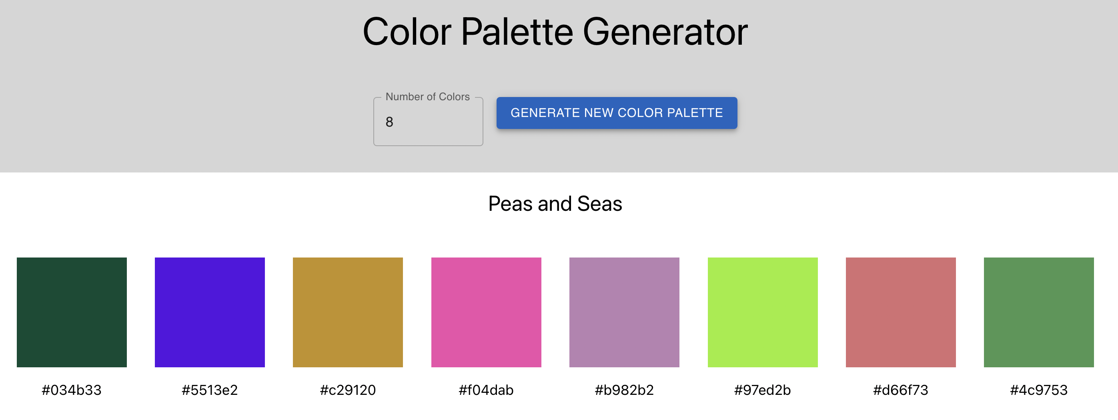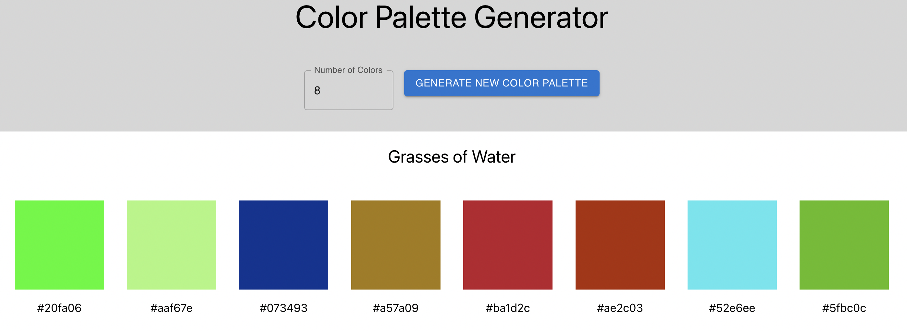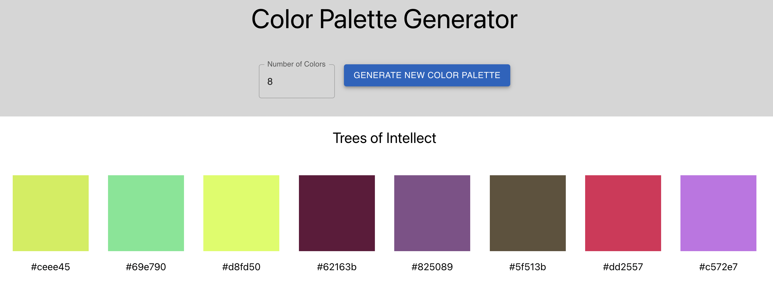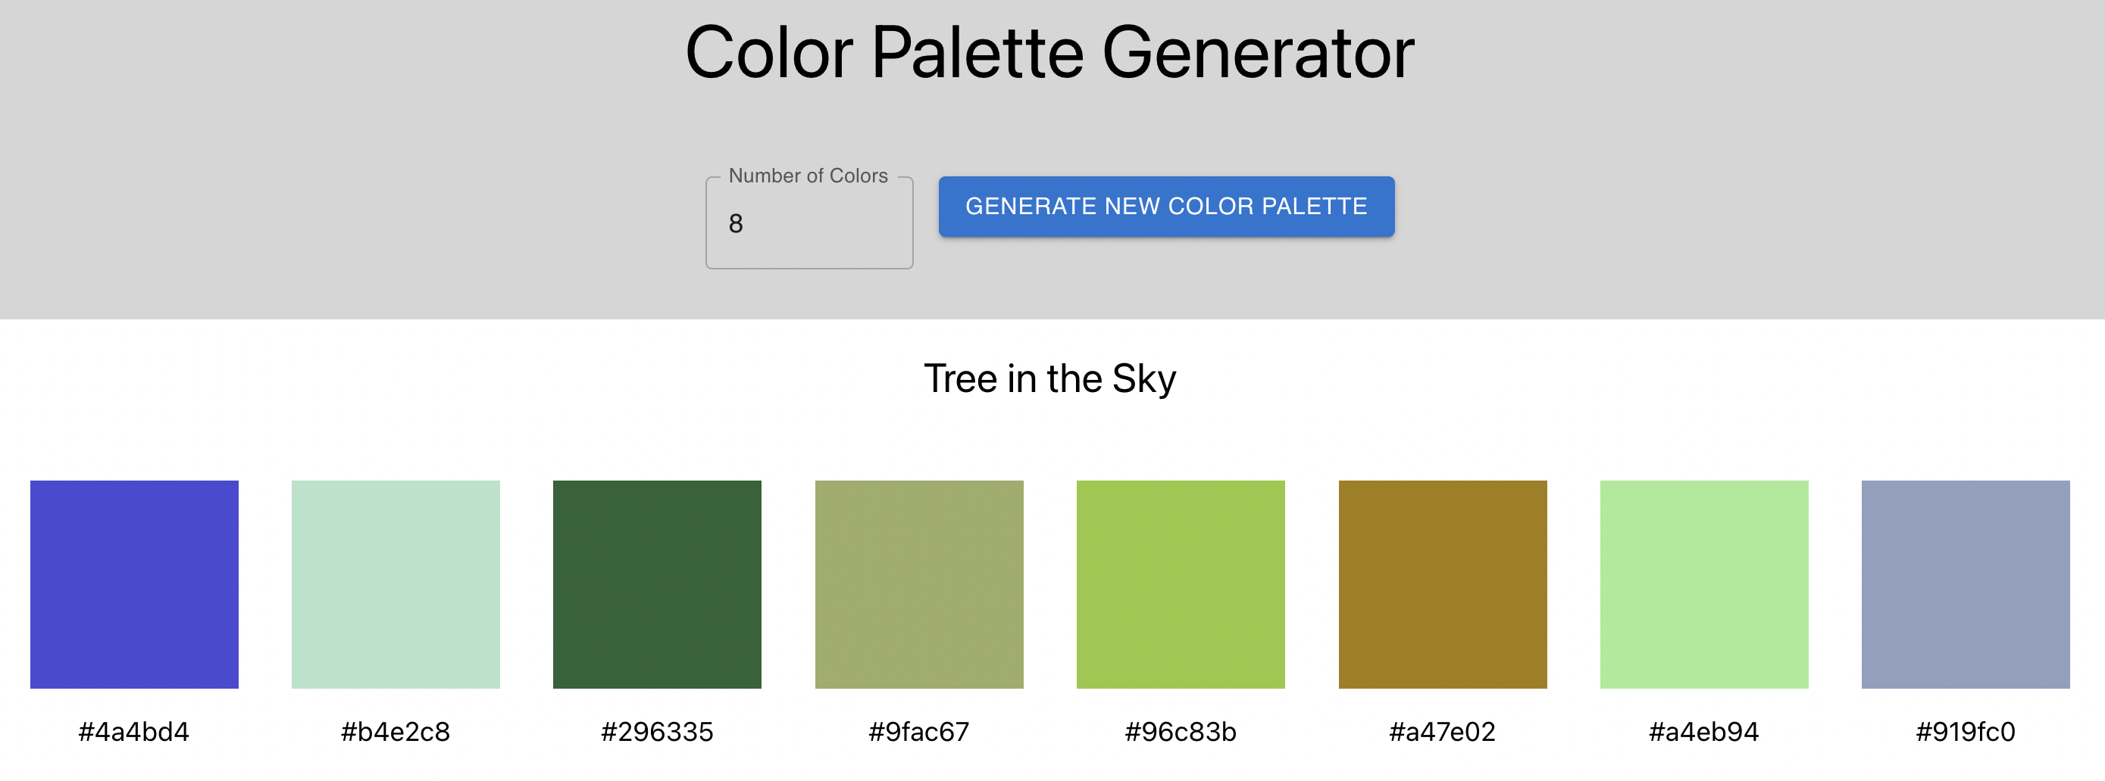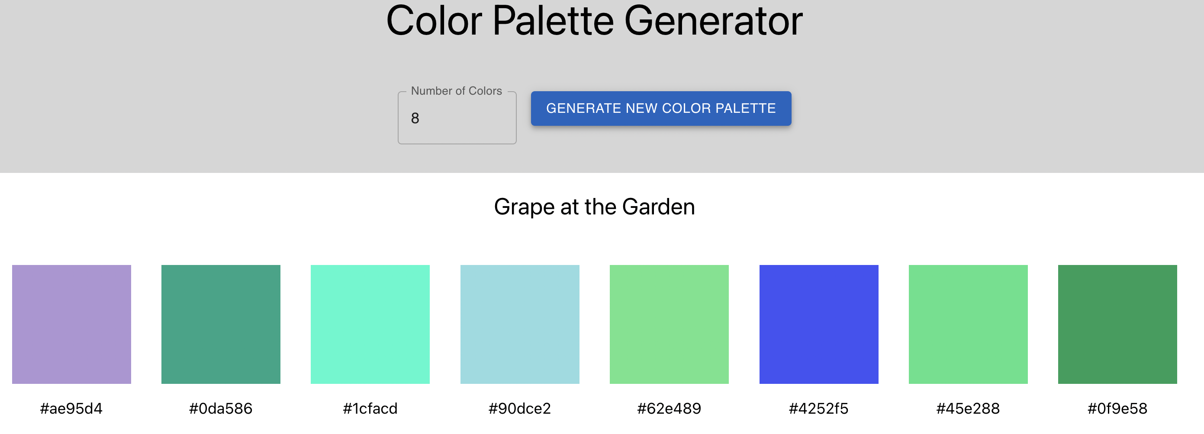

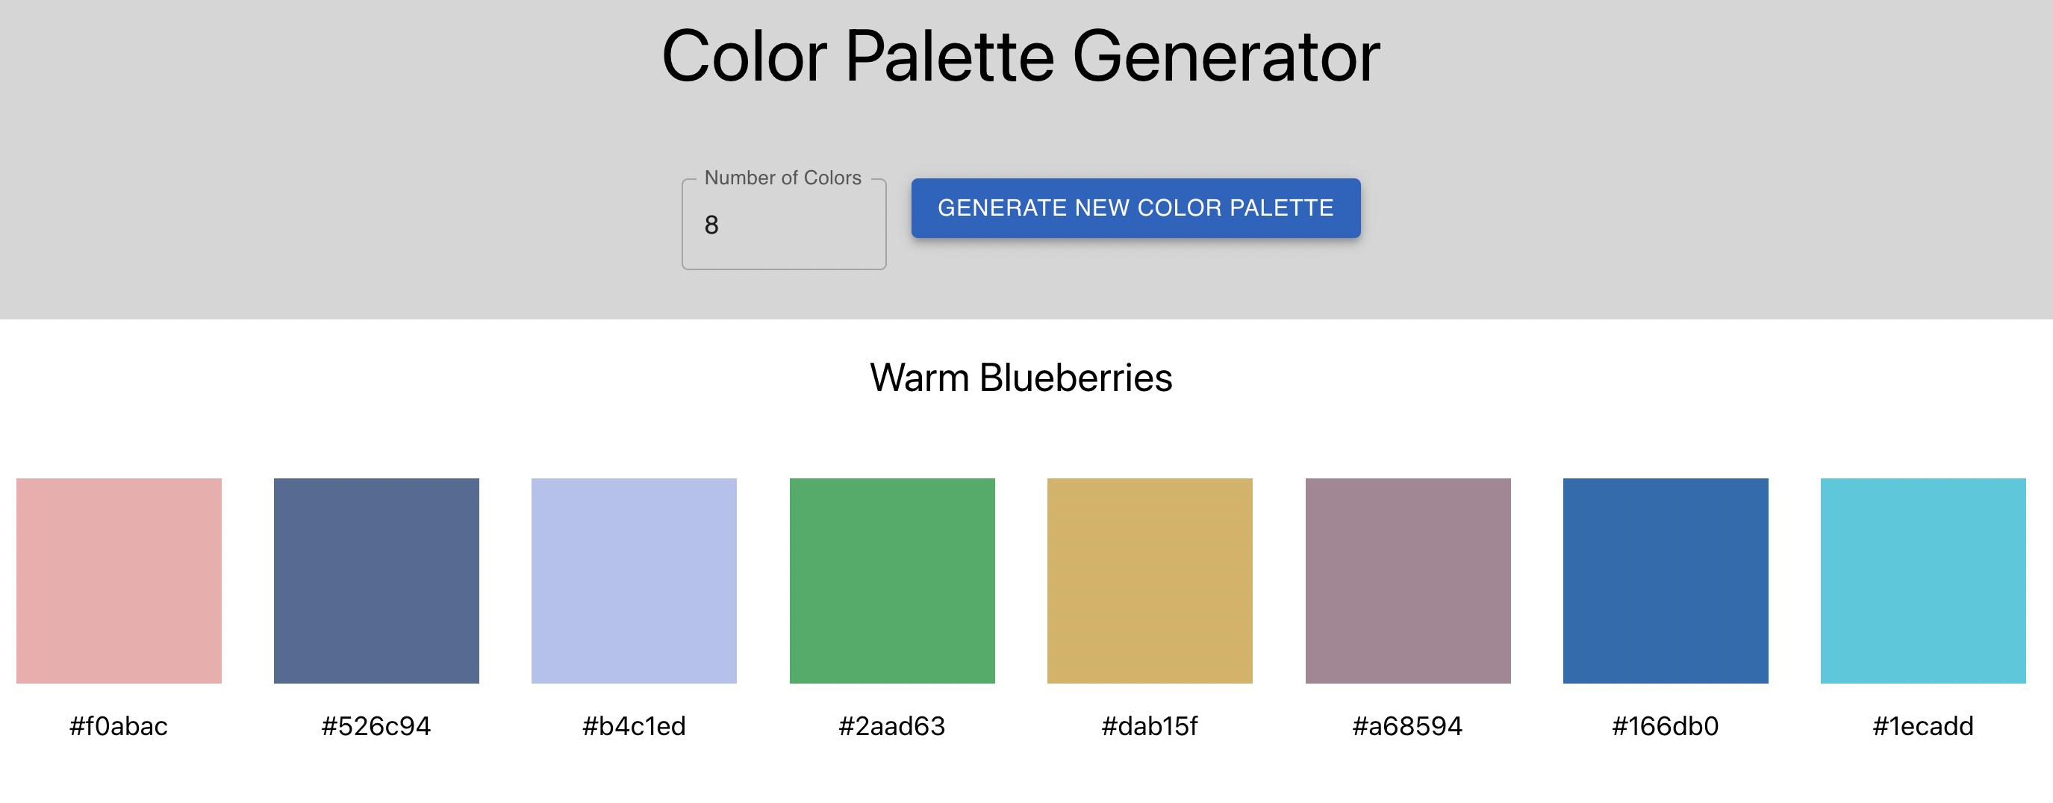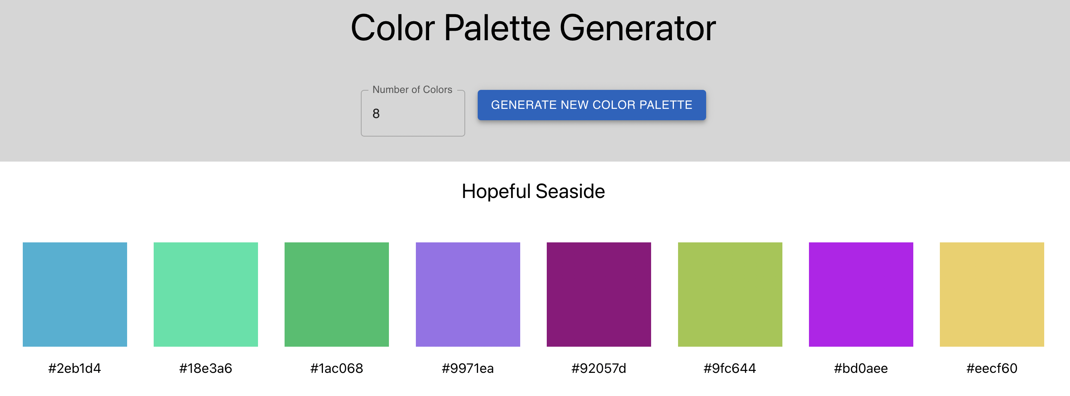

**9. Conclusions**

While this project is not all that I wanted to produce, I will say that I am proud of what I did create. You can see my own interests shine through my project, in the fact that I created a GUI and had a heavy hand in the associations with the colors. I honestly struggled in the beginning to have a clear vision for how to produce this system and often veered off course before coming to this final version. I had many ideas for the naming process that I ran out of time to implement as they would have been too large an upheaval too close to my deadline.

Throughout this project, I determined that creativity in naming color palettes is a challenge, mainly for the reason that there is a fine balance between being creative with the name while still being relevant to the produced palette.

**Acknowledgements**

Thank you to Daniel Flück for his Color Name and Hue tool, as well as his rapid responses to my emails. All the work in this project was done solely by me and none of the core code was obtained from any other projects or people.

**References**

12 Color Meanings - The Power and Symbolism of Colors (Infographics). (2022).

Retrieved 10 April 2022, from <https://www.color-meanings.com/>

Colour association – Style.ONS. (2022). Retrieved 10 April 2022, from

<https://style.ons.gov.uk/data-visualisation/using-colours/colour-> association/#:~:text=yellow%3A%20happy%2C%20fun%2C%20young

purple%3A%20wealth%2C%20mystical%2C%20decadent

Color Name & Hue – Colblindor. (2022). Retrieved 22 April 2022, from

<https://www.color-blindness.com/color-name-hue/>

Color Theory 101: A Complete Color Guide (2022) • Colors Explained. (2022).

Retrieved 10 April 2022, from <https://www.colorsexplained.com/color-theory/>

Guides, D., Policies, S., & Concepts, D. (2022). Divergent and Convergent

Thinking. Retrieved 28 April 2022, from <https://design4services.com/concepts/divergent->and-convergent-thinking/

Symbolism of Color: Using Color for Meaning. (2022). Retrieved 10 April 2022,

from <https://www.incredibleart.org/lessons/middle/color2.htm>

White Things: 103 Things That Are White in Nature (2022) • Colors Explained.

(2022). Retrieved 10 April 2022, from

<https://www.colorsexplained.com/white-things-that-are-white/>